Java script class 1

q-1

create object called product and enter the details

const product =

{

    name: "ball pen",

    rating : 4,

    price : 285,

    dealeoftheday : true,

    offer : "30% of "

};

console.log(product["name"]);

q-2

create object called profile

const profile =

{

    name: "niya dodiya",

    age: 19,

    proffesion: "collageStudent",

    collage : "k s school of business management",

    skilss : "drawing",

    course : "(msc(ca&it)first year)"

};

console.log(profile["name"]);

alert massege on screen

alert("hello ! welcome to js");

there are three types of declare variables

1. var

in the var replace and update are available for the all of the program

exampale:

var a=10;

var a=67;

console.log("a =",a)

1. let

in the let update and replacement are also available in curreley braces {}

let a=20;

{let a=10;

console.log("a =",a)

}

1. const

in the const update and replace are not available the value of variable it is fixed

const a = 56;

const a = 87;

console.log("a -",a)

}

Error: Uncaught SyntaxError: Identifier 'a' has already been declared (at first.js:2:7)

Right case

const a = 56;

// const a = 87;

console.log("a =",a)

class 2

operators and conditional statements

comments

// hello java

Operators in js

// arethmatic operations

let a=5;

let b=2;

console.log("a  =",a);

console.log("b  =",b);

console.log("a + b =",a+b);

// implimentation

console.log("a - b =",a-b);

// decrementation

console.log("a * b =",a*b);

//multiplication

console.log("a / b =",a/b);

// devide

console.log("a ** b =",a**b);

//power

console.log("a % b =",a%b);

//modulo

Output

= 5

first.js:6 b = 2

first.js:8 a + b = 7

first.js:10 a - b = 3

first.js:12 a * b = 10

first.js:14 a / b = 2.5

first.js:16 a ** b = 25

first.js:18 a % b = 1

//only single operand arithmatic

let a=5;

console.log(" a++ =",a++);

//increment post

console.log(" ++a =",++a);

// incremenr pre

//decrement post

console.log(" a-- =",a--);

// decrement pre

console.log(" --a =",--a);

output:

a++ = 5

first.js:6 ++a = 7

first.js:9 a-- = 7

first.js:11 --a = 5

// assigment operator

a=5;

console.log("a += ",a +=4);

console.log("a -= ",a -=4);

console.log("a *= ",a *=4);

console.log("a %= ",a %=4);

console.log("a **= ",a **=4);

console.log("a /= ",a /=2);

a += 9

first.js:5 a -= 5

first.js:6 a *= 20

first.js:7 a %= 0

first.js:8 a **= 0

first.js:9 a /= 0

// logical operator

// equal to

console.log(" a == b",a == b);//true

console.log(" a != b",a != b);//false

a == b true

a != b false

// logical operator

a=10;

b="10";

console.log(" a === b",a === b);//false

console.log(" a !== b",a !== b);// true

a === b false

a !== b true

// logical operator

//&&---->AND

//|| -----> OR

// ! -------> NOT

let a=10;

let b= 20;

console.log("a == b || a != b",a == b || a != b);

console.log("a == b && a != b",a == b && a != b);

a == b || a != b true

first.js:12 a == b && a != b false

// conditional statments

//if conditions

a=34;

b=43;

if(a<40 && b>40)

{

    console.log("true");

}

True

// conditional statments

//if - else conditions

a=67;

b=43;

if(a<40 && b>40)

{

    console.log("true");

}

else

{

    console.log("false");

}

False

// conditional statments

//else-if conditions

a=67;

if(a<100&& a>80)

{

    console.log("a");

}

else if(a<79 && a>60)

{

    console.log("b");

}

else

{

    console.log("c");

}

Output :

B

// ternery operator

 let age = 13;//34= adult

 let result = age > 18 ? "adult": "not adult";

 console.log("result =",result);

﻿result = not adult

q-1

// promote it is use to enter the values

let num = prompt("enter the Number!");

if(num%5 === 0){

    console.log(" num is multiply with 5");

}

else

{

    console.log("num is  not multiply with 5");

}

q-2

always ready

class -3

// //for loop in js

// for(let i=0;i<=5;i++)

// {

// console.log("i =",i);

// }

//while loop

let i=1;

while(i<=10){

    console.log("i =",i)

}

Do while loop

let i=0;

do{

    console.log("i =",i);

}while(i<=10)

For of loop

const variabale = [11,22,33,44,55,66,77,88,99];

for( let value of variabale)

{

    console.log("value =",value);

}

value = 11

first.js:5 value = 22

first.js:5 value = 33

first.js:5 value = 44

first.js:5 value = 55

first.js:5 value = 66

first.js:5 value = 77

first.js:5 value = 88

first.js:5 value = 99

for in loop

const variabale = [11,22,33,44,55,66,77,88,99];

for( let value in variabale)

{

    console.log("value of index=",value);

}

value of index= 0

first.js:5 value of index= 1

first.js:5 value of index= 2

first.js:5 value of index= 3

first.js:5 value of index= 4

first.js:5 value of index= 5

first.js:5 value of index= 6

first.js:5 value of index= 7

first.js:5 value of index= 8

practice qutions

print all even numbers 1 to 100

for(i=1;i<=100;i++){

    if(i%2 === 0){

        console.log("even numbers =",i);

    }

    else

    {

        console.log("eodd numbers =",i);

    }

}

﻿

first.js:7 eodd numbers = 1

first.js:3 even numbers = 2

first.js:7 eodd numbers = 3

first.js:3 even numbers = 4

first.js:7 eodd numbers = 5

first.js:3 even numbers = 6

first.js:7 eodd numbers = 7

first.js:3 even numbers = 8

first.js:7 eodd numbers = 9

first.js:3 even numbers = 10

first.js:7 eodd numbers = 11

first.js:3 even numbers = 12

first.js:7 eodd numbers = 13

first.js:3 even numbers = 14

first.js:7 eodd numbers = 15

first.js:3 even numbers = 16

first.js:7 eodd numbers = 17

first.js:3 even numbers = 18

first.js:7 eodd numbers = 19

first.js:3 even numbers = 20

first.js:7 eodd numbers = 21

first.js:3 even numbers = 22

first.js:7 eodd numbers = 23

first.js:3 even numbers = 24

first.js:7 eodd numbers = 25

first.js:3 even numbers = 26

first.js:7 eodd numbers = 27

first.js:3 even numbers = 28

first.js:7 eodd numbers = 29

first.js:3 even numbers = 30

first.js:7 eodd numbers = 31

first.js:3 even numbers = 32

first.js:7 eodd numbers = 33

first.js:3 even numbers = 34

first.js:7 eodd numbers = 35

first.js:3 even numbers = 36

first.js:7 eodd numbers = 37

first.js:3 even numbers = 38

first.js:7 eodd numbers = 39

first.js:3 even numbers = 40

first.js:7 eodd numbers = 41

first.js:3 even numbers = 42

first.js:7 eodd numbers = 43

first.js:3 even numbers = 44

first.js:7 eodd numbers = 45

first.js:3 even numbers = 46

first.js:7 eodd numbers = 47

first.js:3 even numbers = 48

first.js:7 eodd numbers = 49

first.js:3 even numbers = 50

﻿

Console

What's new

q-2 create a game for user when userask the number is right when the number is correct

const num = 25;

 var value=prompt("enter the number");

for(let i=0; value != num; i++)

{

    var value=prompt("enter the correct number");

}

console.log(" your choice is right you are enter the correct number:");

your choice is right you are enter the correct number:

string

create string

let string = “niya dodiya”;

string leanth

let string = "niya dodiya";

console.log(string);

console.log(string.length);

niya dodiya

11

let string = "niya dodiya";

console.log(string);

console.log(string.length);

console.log(`the lady of theday is ${string} and lenth is ${string.length}`);

niya dodiya

first.js:3 11

first.js:4 the lady of theday is niya dodiya and lenth is 11

escape the character

// create next line and tab

console.log(" for the next line niya \n dodiya");

console.log(" for the tab niya \t dodiya");

for the next line niya

dodiya

first.js:3 for the tab niya dodiya

// create next line and tab

let string = "niya dodiya";

let str = " k s school of business management ,ahemdabad";

console.log(string.toUpperCase());

console.log(string.toLowerCase());

console.log(string.trim());

console.log(string.slice(0,4));

console.log(string.concat(str));

console.log(string.replace("niya dodiya" ,"prem dodiya"));

console.log(string.charAt(7));//d

NIYA DODIYA

first.js:6 niya dodiya

first.js:7 niya dodiya

first.js:9 niya

first.js:10 niya dodiya k s school of business management ,ahemdabad

first.js:11 prem dodiya

first.js:12 d

// prctice qution

let fullname = prompt("enter the username");

let username =  "@" + fullname + fullname.length;

console.log(username);

@niyadodiya10

Class 4

Arrays

//arrays

const foods = ["burger","chips","pizza","panner","cheez","salsa","salad","naan"];

for( let food of foods ){

    console.log("food item =",food);

}

food item = burger

first.js:5 food item = chips

first.js:5 food item = pizza

first.js:5 food item = panner

first.js:5 food item = cheez

first.js:5 food item = salsa

first.js:5 food item = salad

first.js:5 food item = naan

//prectice qution

//find average of students marks

let marks = [85,97,44,37,76,60];

let sum = 0;

for( let value of marks){

     sum += value;

}

console.log("average =",sum/6);

average = 66.5

q-2

every item shold have 10% discount and lastly find the price

250,645,300,900,50

let pro =[250,645,300,900,50];

let discount;

for(let i = 0; i<pro.length; i++){

discount = pro[i]/10;

pro[i]=pro[i]-discount;

console.log("items =",pro[i]

}

items = 225

first.js:7 items = 580.5

first.js:7 items = 270

first.js:7 items = 810

first.js:7 items = 45

array method

//arrays

let food = ["burger","chips","pizza","panner","cheez","salsa","salad","naan"];

let vaggies = ["tomato","patato","ladyfinger"];

//push method

food.push("daal-fry & jeera rice");

console.log(food);

//pop method

food.pop();

console.log(food);

//to string

food.toString();

console.log(food);

// unsift add to start

food.unshift("daal-fry & jeera rice");

console.log(food);

// delete at first

food.shift();

console.log(food);

// slice return a place of array

 let sli = food.slice(0,3);

console.log(sli);

// splice change the origin of the array

food.splice(2,0,"french-fries")

console.log(food);

first.js:10 (8) ['burger', 'chips', 'pizza', 'panner', 'cheez', 'salsa', 'salad', 'naan']

first.js:13 (8) ['burger', 'chips', 'pizza', 'panner', 'cheez', 'salsa', 'salad', 'naan']

first.js:16 (9) ['daal-fry & jeera rice', 'burger', 'chips', 'pizza', 'panner', 'cheez', 'salsa', 'salad', 'naan']

first.js:19 (8) ['burger', 'chips', 'pizza', 'panner', 'cheez', 'salsa', 'salad', 'naan']

first.js:22 (3) ['burger', 'chips', 'pizza']

first.js:25 (9) ['burger', 'chips', 'french-fries', 'pizza', 'panner', 'cheez', 'salsa', 'salad', 'naan']

prectice qution

create a componies

honda,nayaka,nivya,tata,birla

let componies =["honda","nayaka","nivya","tata","birla"];

//delete first shift

componies.shift();

console.log(componies);

// delete tata and add ola to the place

componies.splice(2,1,"ola");

console.log(componies);

//in the last add compony amazon

componies.push("Amazon");

console.log(componies);

1. *(4) ['nayaka', 'nivya', 'tata', 'birla']*

first.js:7

1. *(4) ['nayaka', 'nivya', 'ola', 'birla']*

first.js:10

1. *(5) ['nayaka', 'nivya', 'ola', 'birla', 'Amazon']*
   1. **0**: "nayaka"
   2. **1**: "nivya"
   3. **2**: "ola"
   4. **3**: "birla"
   5. **4**: "Amazon"
   6. **length**: 5
   7. [[Prototype]]: Array(0)

Class -5

Functions & methods

Create function to ca;culate sum of two numbers

// calculate sum of two numbres using function call

function sum(a ,b){

    console.log(" sum of a+b =",a+b);

}

sum(89,87);

sum = 176

arrow function

// calculate sum of two numbres using function call

const mul = (a,b) => {

    console.log(" multipliction of a*b =",a*b);

}

mul(89,87);

multiplication 7743

//prectice q-1return a number of vowel

function vowel(msg){

    let count;

for(const vaar of msg){

    if(vaar === "a" || vaar === "e" || vaar === "i" || vaar === "o" || vaar === "u")

    {

        count++;

        console.log(vaar);

    }}}

vowel("niyadodiya");

i

first.js:9 a

first.js:9 o

first.js:9 i

first.js:9 a

q-2 create arrow function to perform specific task

//prectice q-1return a number of vowel

const vowel = (msg) => {

    let count;

for(const vaar of msg){

    if(vaar === "a" || vaar === "e" || vaar === "i" || vaar === "o" || vaar === "u")

    {

        count++;

        console.log(vaar);

    }}

return count;

}

vowel("niyadodiya");

same output as q-1

for each loop

// for each loop

let array = [11,22,33,44,55,66,77];

array.forEach((value) => {

    console.log(value);

});

11

first.js:5 22

first.js:5 33

first.js:5 44

first.js:5 55

first.js:5 66

first.js:5 77

practice qution

square of each number inarray

// for each loop

let array = [11,22,33,44,55,66,77];

array.forEach((value) => {

    console.log(value*value);

});

121

first.js:5 484

first.js:5 1089

first.js:5 1936

first.js:5 3025

first.js:5 4356

first.js:5 5929

array method

map

filter

// map

let array = [11,22,33,44,55,66,77];

let newarray = array.map((value) => {

    console.log(value*2);

});

// filter

let array1 = [11,22,33,44,55,66,77];

let newarray1 = array.filter((value) => {

    console.log(value*2);

});

22

first.js:5 44

first.js:5 66

first.js:5 88

first.js:5 110

first.js:5 132

first.js:5 154

Answer of filter

first.js:11 22

first.js:11 44

first.js:11 66

first.js:11 88

first.js:11 110

first.js:11 132

first.js:11 154

reduce

// reduce

let array = [11,22,33,44,55,66,77];

let output = array.reduce((res,curr) => {

    return res+curr;

});

console.log(output);

308

Practice qution 1

//class 5 prectice q-1

//filter the marks above the 90+

let marks=[12,89,98,97,94,91,90,45,63,45,3,12,74,98];

let highscore = marks.filter((value) =>

{

return value>90;

})

console.log(highscore);

1. *(5) [98, 97, 94, 91, 98]*
   1. **0**: 98
   2. **1**: 97
   3. **2**: 94
   4. **3**: 91
   5. **4**: 98
   6. **length**: 5
   7. [[Prototype]]: Array(0)

q-2

//class 5 prectice q-2

// take n number input to user

let n = prompt("enter the number");

let arr = [];

for(let i = 1; i<=n; i++){

    arr[i-1]=i;

}

//use reduce method to calculate sum

let newarr = arr.reduce((res,curr) => {

    return res+curr;

});

console.log("sum =",newarr);

//use reduce method to calculate product

let newarr1 = arr.reduce((res,curr) => {

    return res*curr;

});

console.log("product =",newarr1);

Output

sum = 55

product = 3628800

Class 6

DOM

DOCUMNENT OBJECT MODEL

WINDOWS

PRENT NODES

DOCUMENT

HTML

V

BODY

HEAD

DIV

SCRIPT

LINK

TITLE

META

META

DIV

P

H1

IMG

// class 6

//DOM

//WINDOWS ARE ALREADY DEFINED

console.dir(document.body);

output

body

// dom manipulation

//selecting id/class/tag

let id = document.getElementById("myid");

console.log(id);

let class1 = document.getElementsByClassName("myclass");

console.log(class1);

let tag = document.getElementsByTagName("h2");

console.log(tag);

<p id="myid">this is my paragraph</p>

first.js:9 HTMLCollection [div.myclass]

first.js:12 HTMLCollection [h2#myid2, myid2: h2#myid2]

html code

<!DOCTYPE html>

<html lang="en">

<head>

    <meta charset="UTF-8">

    <meta name="viewport" content="width=device-width, initial-scale=1.0">

    <title>Document</title>

</head>

<body>

</body>

<div class="myclass">

    <p id="myid">this is my paragraph</p>

     <h2 id="myid2">this is my h2</h2>

</div>

<h1> dom demo </h1>

<script src="first.js"></script>

</html>

Java script code

//query selector

let id = document.querySelector("#myid");

console.log(id);

let id1 = document.querySelector("#myid2");

console.log(id1);

// for class

let class1 = document.querySelector(".myclass");

console.log(class1);

//for tag

let tag = document.querySelector("p");

console.log(tag);

<p id="myid">this is my paragraph</p>

<h2 id="myid2">this is my h2</h2>

<div class="myclass">

<p id="myid">this is my paragraph</p>

<h2 id="myid2">this is my h2</h2>

</div>

<p id="myid">this is my paragraph</p>

//inner html

let id = document.querySelector("#myid").innerHTML;

console.log(id);

//inner text

let id1 = document.querySelector("#myid2").innerText;

console.log(id1);

//inner textcontent

let class1 = document.querySelector(".myclass").textContent;

console.log(class1);

class1.innerHTML;

let tag = document.querySelector("p").innerText;

console.log(tag);

this is my paragraph

first.js:7 this is my h2

first.js:12

this is my paragraph

this is my h2

first.js:17 this is my paragraph

class 7

//class 7 DOM part 2

//dom manuplation (attributes)

//getattribute

let para = document.querySelector("div");

console.log(para);

let id = para.getAttribute("class");

console.log(id);

<div class="myclass">…</div>

Myclass

//getattribute

let para = document.querySelector("p");

console.log(para);

let id = para.getAttribute("id");

console.log(id);

let para1 = document.querySelector("h2");

console.log(para1);

let id1 = para1.getAttribute("id");

console.log(id1);

    <p id="myid">this is my paragraph</p>

myid

first.js:11 <h2 id=​"myid2">​this is my h2​</h2>​

first.js:13 myid2

//setattribute

let para = document.querySelector("p");

console.log(para);

let id = para.setAttribute("id","niya");

console.log(id);

<p id="niya">this is my paragraph</p>

// insert element

let ul = document.querySelector("div");

ul.style.backgroundColor = "green";

ul.style.textAlign = "center";

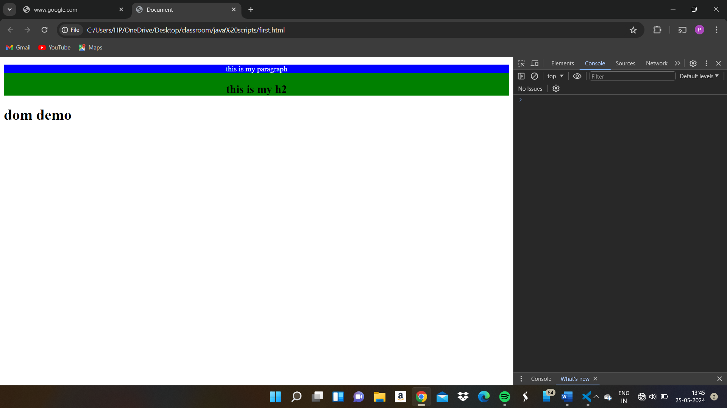

//node.append(el)

let newbtn = document.createElement("button");

newbtn.innerText = "click me!";

let div = document.querySelector("div");

div.append(newbtn);

//node prepend

let newbtn1 = document.createElement("button");

newbtn.innerText = "click me!";

let div1 = document.querySelector("div");

div1.prepend(newbtn1);

<!DOCTYPE html>

<html lang="en">

<head>

    <meta charset="UTF-8">

    <meta name="viewport" content="width=device-width, initial-scale=1.0">

    <title>Document</title>

    <link rel="stylesheet" href="style.css">

</head>

<body>

</body>

<button onclick="console.log('this button is click now');alert('hello js!')">click me!</button>

<script src="first.js"></script>

</html>

first.html:11 this button is click now

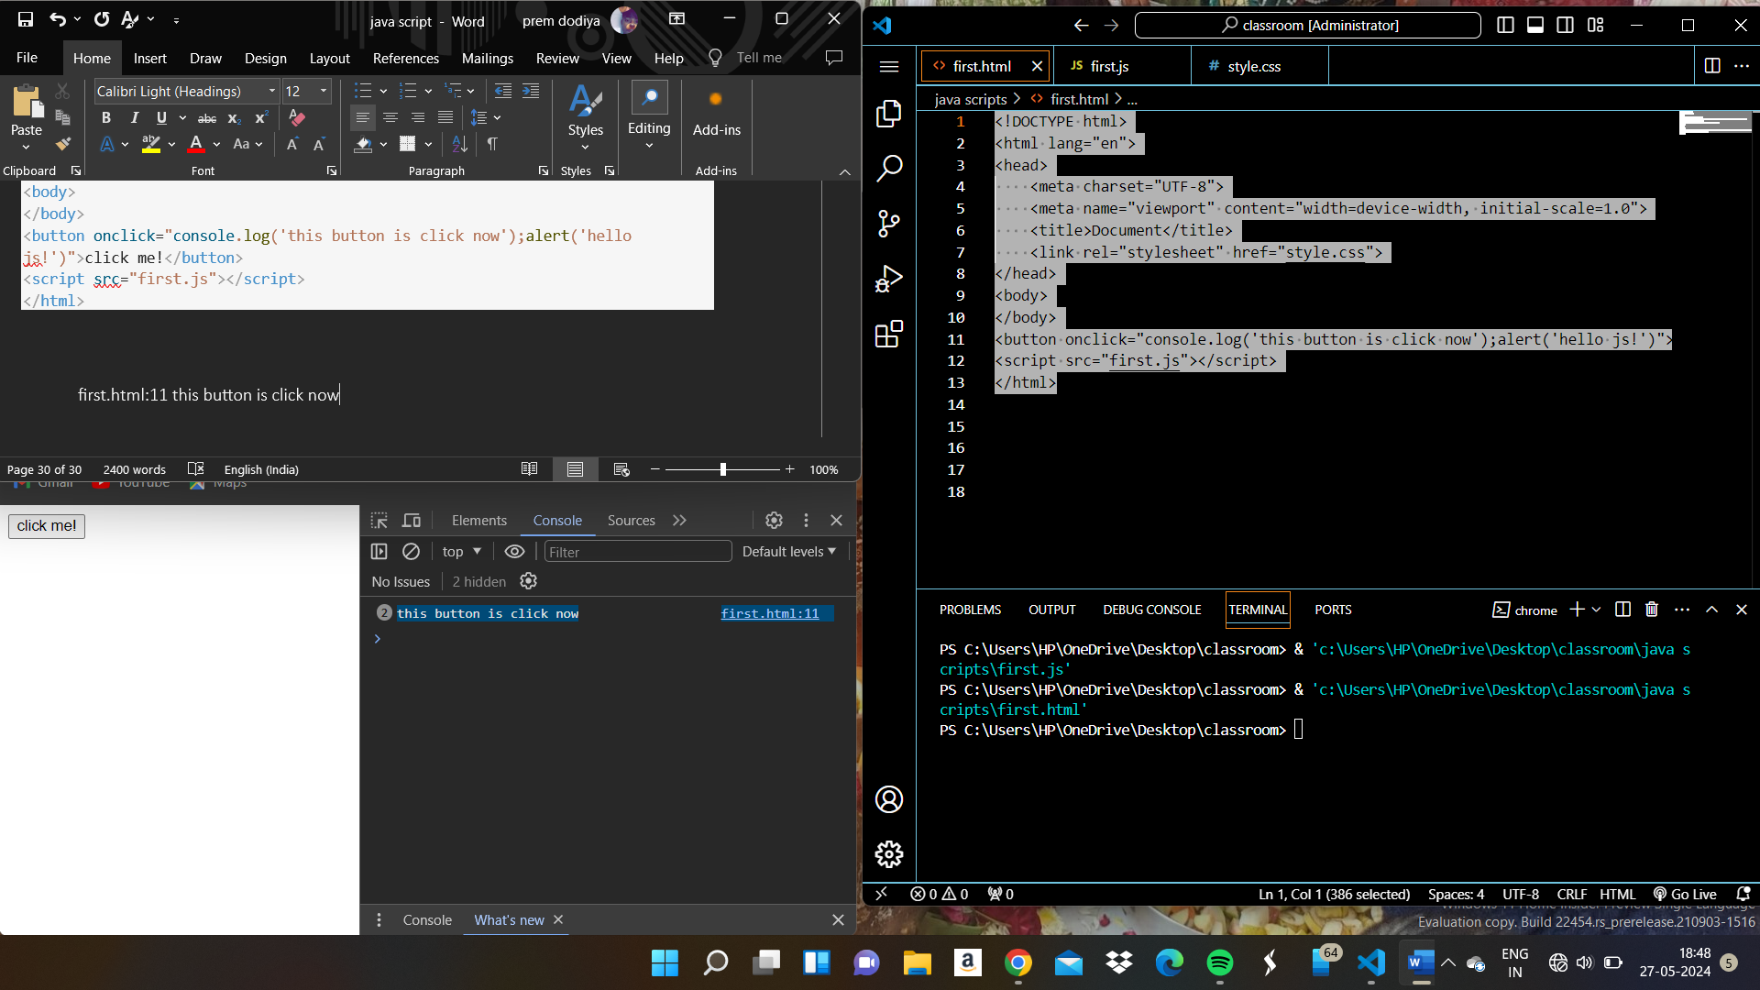

<!DOCTYPE html>

<html lang="en">

<head>

    <meta charset="UTF-8">

    <meta name="viewport" content="width=device-width, initial-scale=1.0">

    <title>Document</title>

    <link rel="stylesheet" href="style.css">

</head>

<body>

</body>

<button onclick="console.log('this button is click now');alert('hello js!')">click me!</button>

<button ondblclick="console.log('this button is click now 2x');alert('button click 2x times')">click me 2x times!</button>

<script src="first.js"></script>

</html>

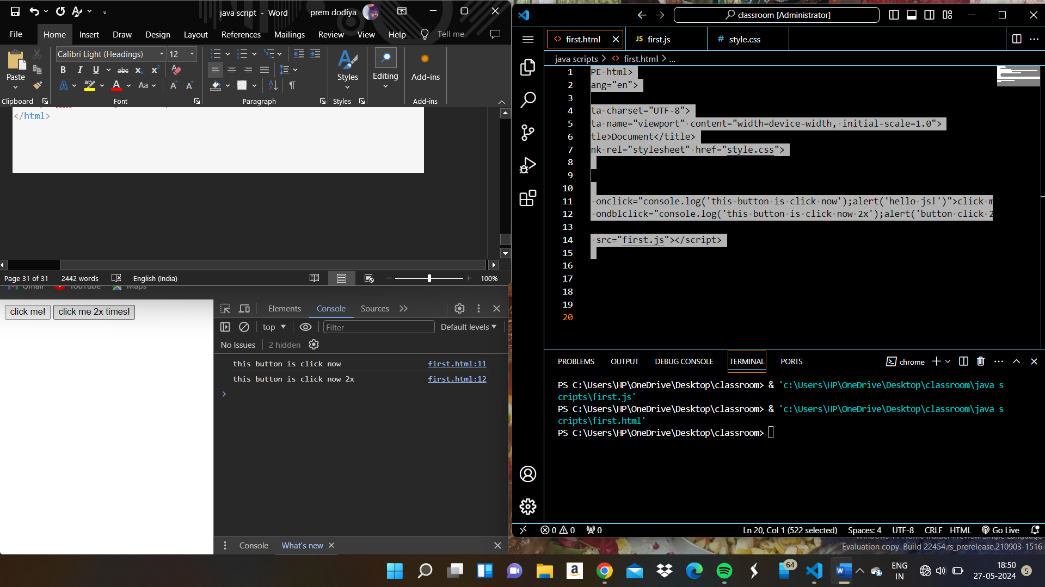

Event hendaling in java script

Node.event = () => {

//handale here

}

Html code

<!DOCTYPE html>

<html lang="en">

<head>

    <meta charset="UTF-8">

    <meta name="viewport" content="width=device-width, initial-scale=1.0">

    <title>Document</title>

    <link rel="stylesheet" href="style.css">

</head>

<body>

<button id="btn1">click me!</button>

<button ondblclick="console.log('this button is click now 2x');alert('button click 2x times')">click me 2x times!</button>

<script src="first.js"></script>

</body>

</html>

Java Script code

let bt1 = document.querySelector("#btn1");

 bt1.onclick = () => {

    console.log("the btn 1 is clicked");

    alert("button 1 was clicked");

 };

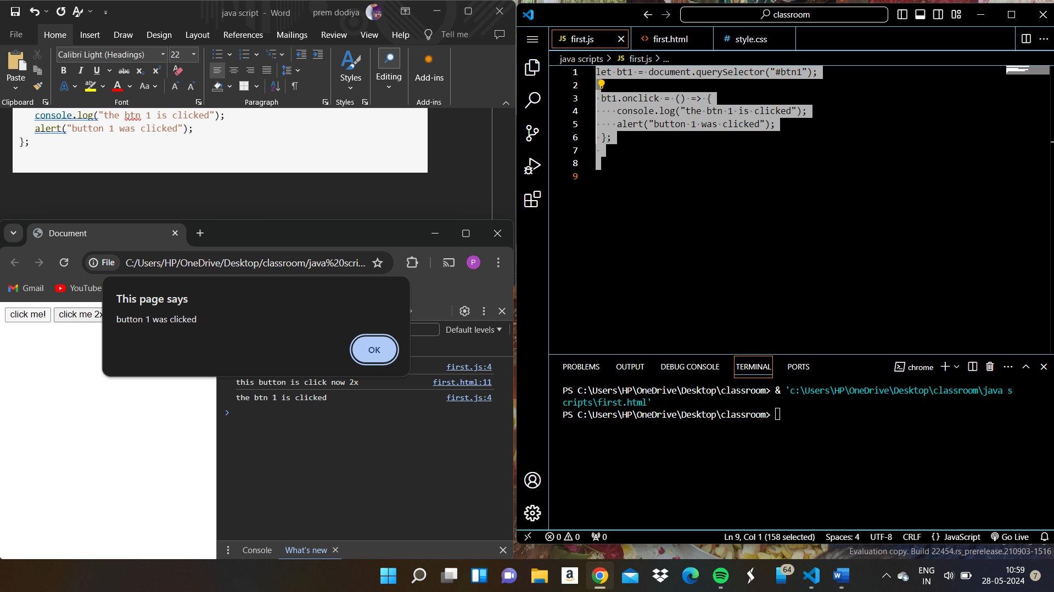

Button 1 is java scripts handaling

Button 2 is inline handaling

Event objects in java script

e.type

e.target

e.clientx

e.clienty

e

let bt1 = document.querySelector("#btn1");

 bt1.onclick = (evn) => {

    console.log("the btn 1 is clicked");

    alert("button 1 was clicked");

    console.log(evn.type);

    console.log(evn);

    console.log(evn.target);

    console.log(evn.clientX);

    console.log(evn.clientY);

 };

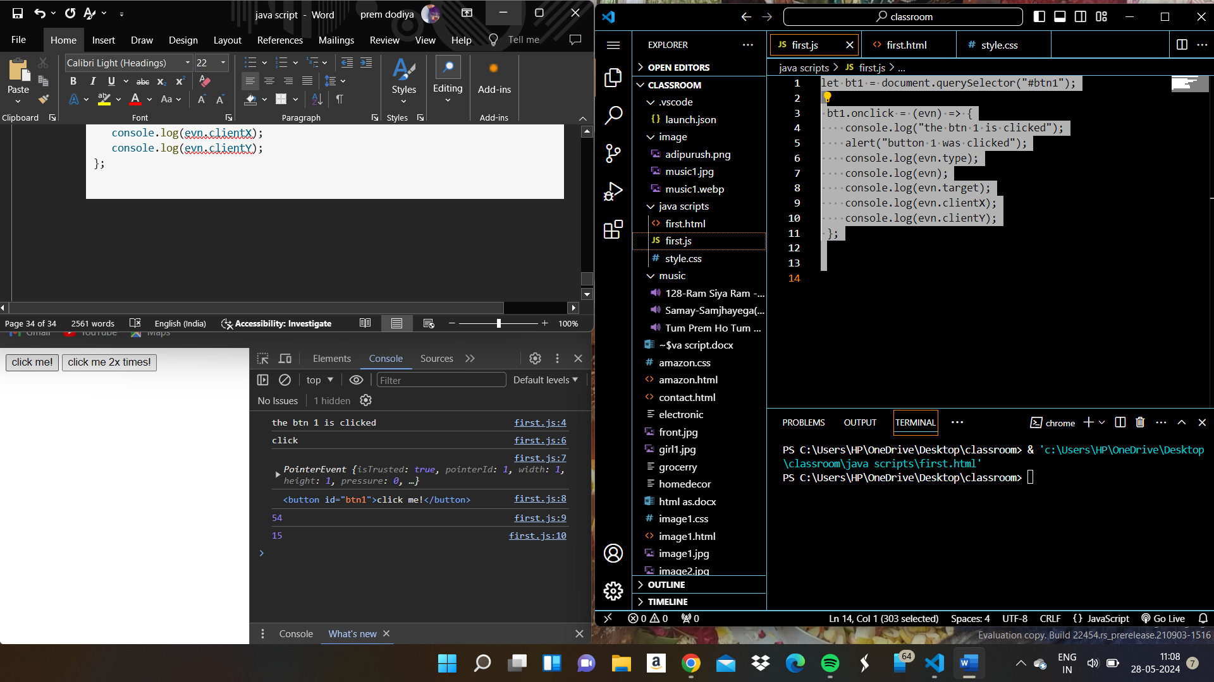

Event listners

Node.addEventListner(event,callback);

Node.removeEventListner(event,callback);

let bt1 = document.querySelector("#btn1");

//  bt1.onclick = (evn) => {

//     console.log("the btn 1 is clicked");

//     alert("button 1 was clicked");

//     console.log(evn.type);

//     console.log(evn);

//     console.log(evn.target);

//     console.log(evn.clientX);

//     console.log(evn.clientY);

//  };

bt1.addEventListener("click", (evn) => {

        console.log("handaling 1");

        alert("button 1 was clicked");

        console.log(evn.type);

});

bt1.addEventListener("click", () => {

    console.log("handaling 2");

    alert("button 1 was clicked");

});

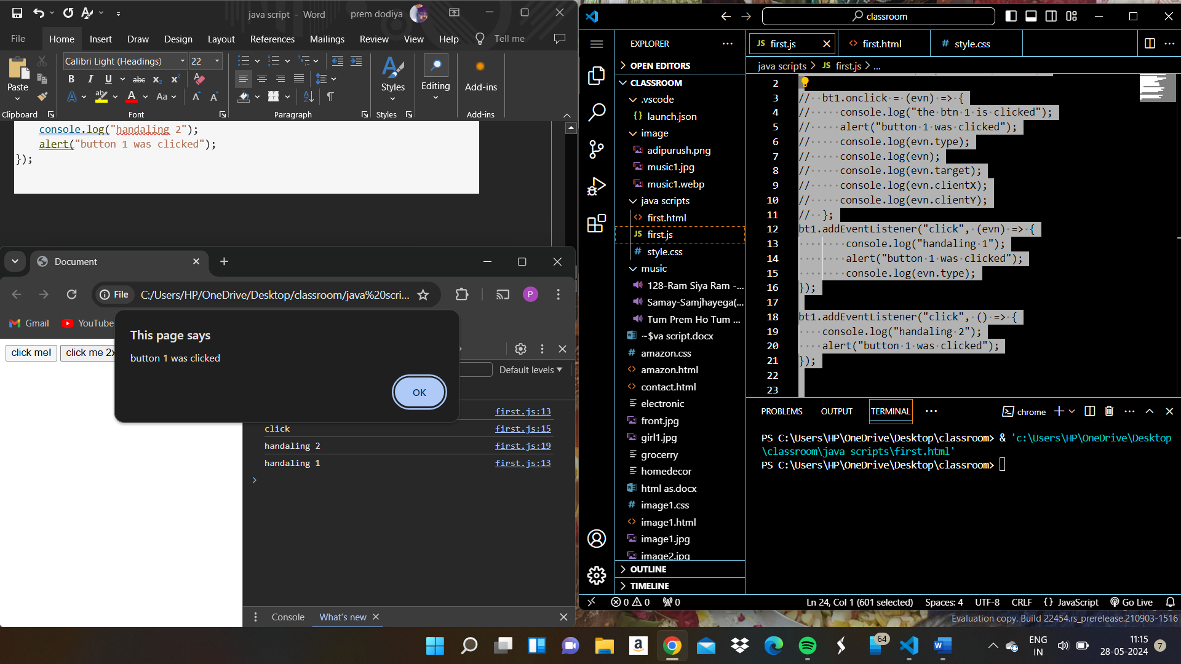

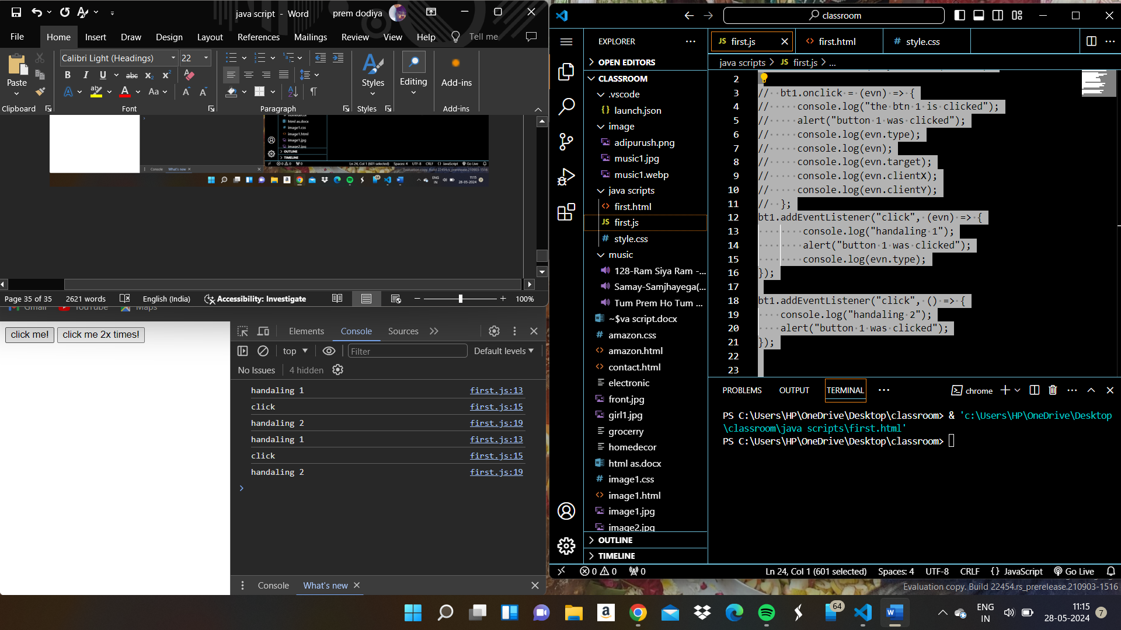

let bt1 = document.querySelector("#btn1");

//  bt1.onclick = (evn) => {

//     console.log("the btn 1 is clicked");

//     alert("button 1 was clicked");

//     console.log(evn.type);

//     console.log(evn);

//     console.log(evn.target);

//     console.log(evn.clientX);

//     console.log(evn.clientY);

//  };

bt1.addEventListener("click", () => {

        console.log("handaling 1");

        alert("button 1 was clicked");

});

const hendler3 = () => {

    console.log("handaling 2");

    alert("button 1 was clicked");

};

bt1.addEventListener("click", hendler3);

bt1.addEventListener("click", () => {

    console.log("handaling 3");

    alert("button 1 was clicked");

});

bt1.addEventListener("click", () => {

    console.log("handaling 4");

    alert("button 1 was clicked");

});

// this both function allocate diffrent memory location

// bt1.removeEventListener("click", () => {

//     console.log("handaling 2");

//     alert("button 1 was clicked");

// });

bt1.removeEventListener("click", hendler3);

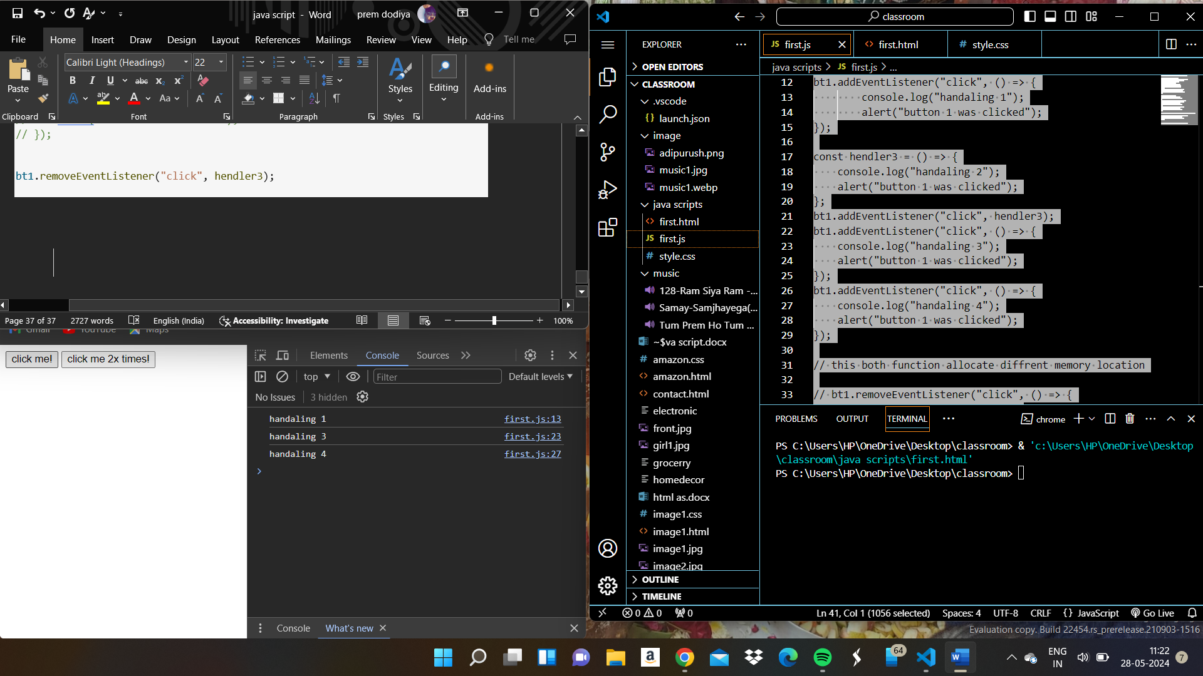

Practice Question 1

//prectice qution 1

let btn = document.querySelector("#btn");

let currmode = "light";

btn.addEventListener("click", () => {

    //console.log("change the background color once")

    //btn.style.backroundColor = black;

    if(currmode === "light"){

        currmode = "dark";

        document.querySelector("body").style.backgroundColor = "black";

    }

    else{

        currmode = "light";

        document.querySelector("body").style.backgroundColor = "grey";

    }

});

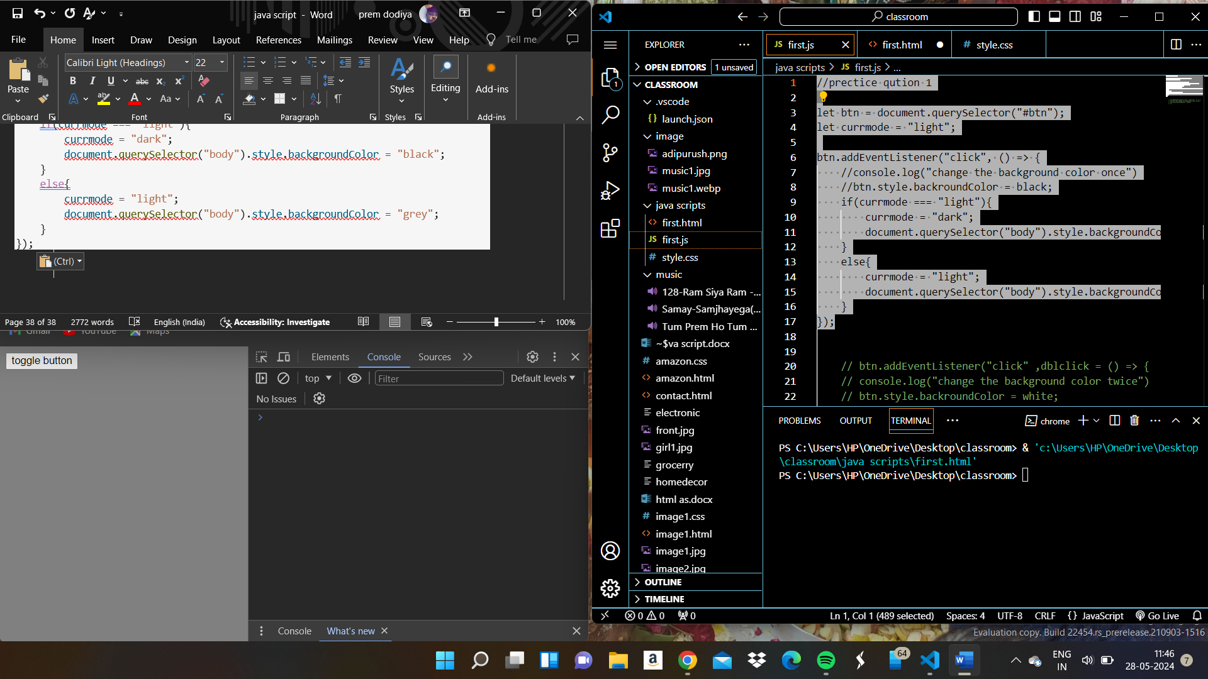

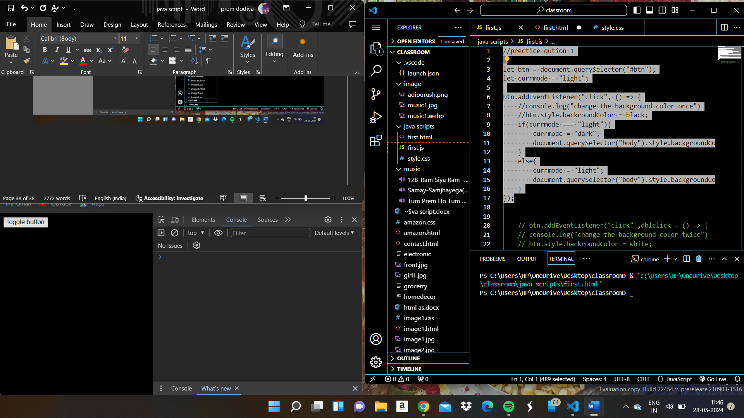

I try to new question one click color is grey and double click color is black:

//prectice qution 1

let btn = document.querySelector("#btn");

//let currmode = "light";

btn.addEventListener("click", () => {

          //currmode = "dark";

        document.querySelector("body").style.backgroundColor = "grey";

});

btn.addEventListener("dblclick", () => {

    //currmode = "dark";

  document.querySelector("body").style.backgroundColor = "black";

});

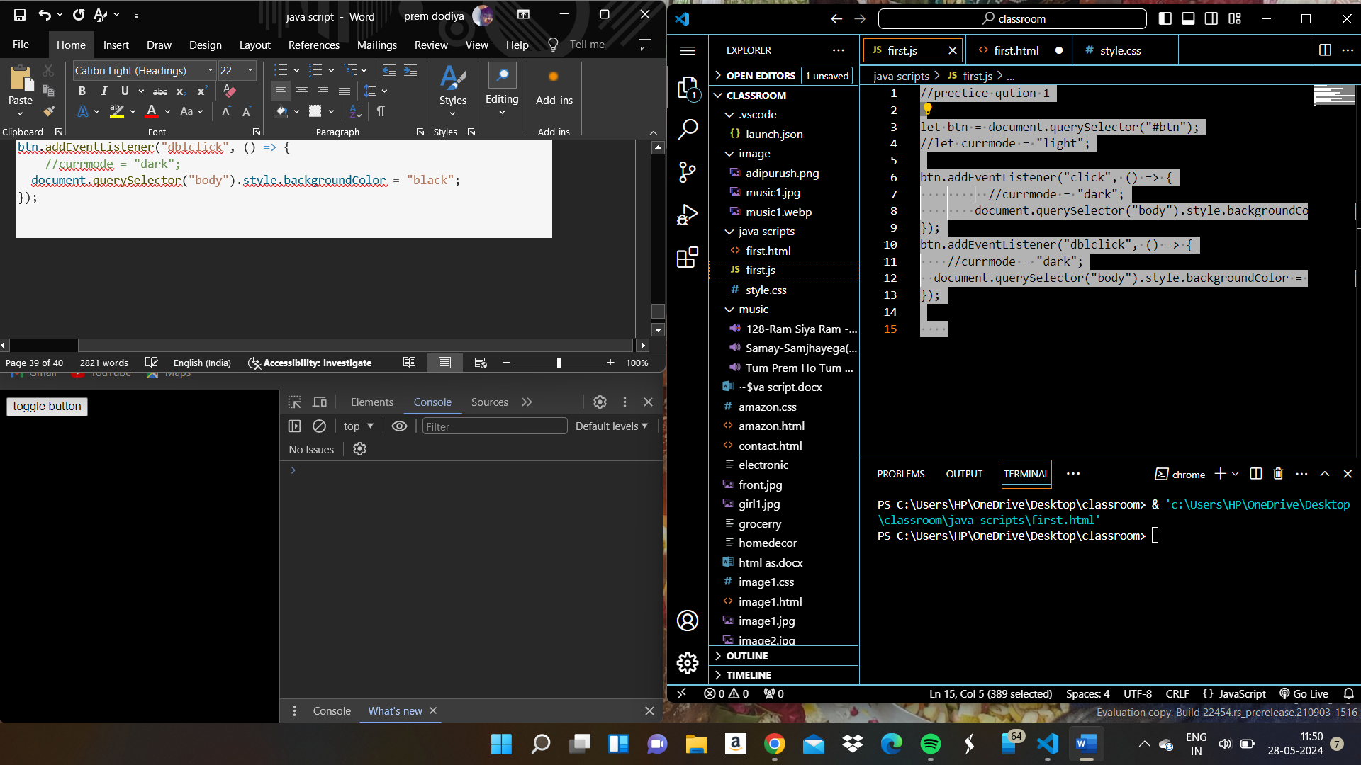

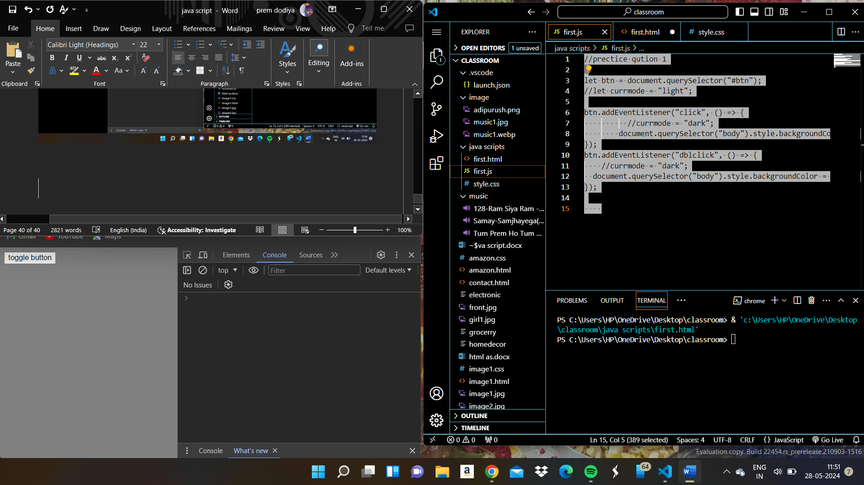

Java script

//prectice qution 1

let btn = document.querySelector("#btn");

let body =  document.querySelector("body");

btn.addEventListener("click", () => {

          //currmode = "dark";

        body.classList.add("dark");

});

btn.addEventListener("dblclick", () => {

    //currmode = "dark";

    body.classList.add("light");

});

Style.css

.dark{

 background-color: black;

 color: aliceblue;

}

.light

{

    background-color: aliceblue;

    color: black;

}

Html

<!DOCTYPE html>

<html lang="en">

<head>

    <meta charset="UTF-8">

    <meta name="viewport" content="width=device-width, initial-scale=1.0">

    <title>Document</title>

    <link rel="stylesheet" href="style.css">

</head>

<body>

<button id="btn">toggle button</button>

<p> welcome to the website</p>

<script src="first.js"></script>

</body>

</html>

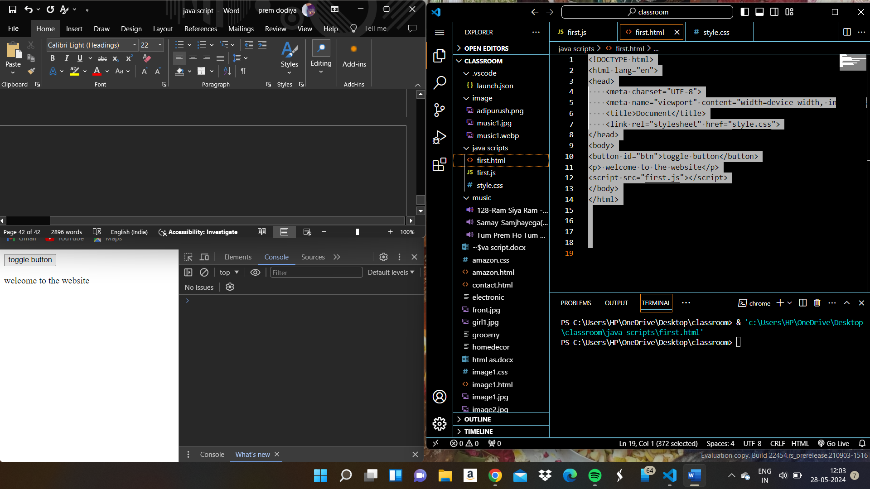

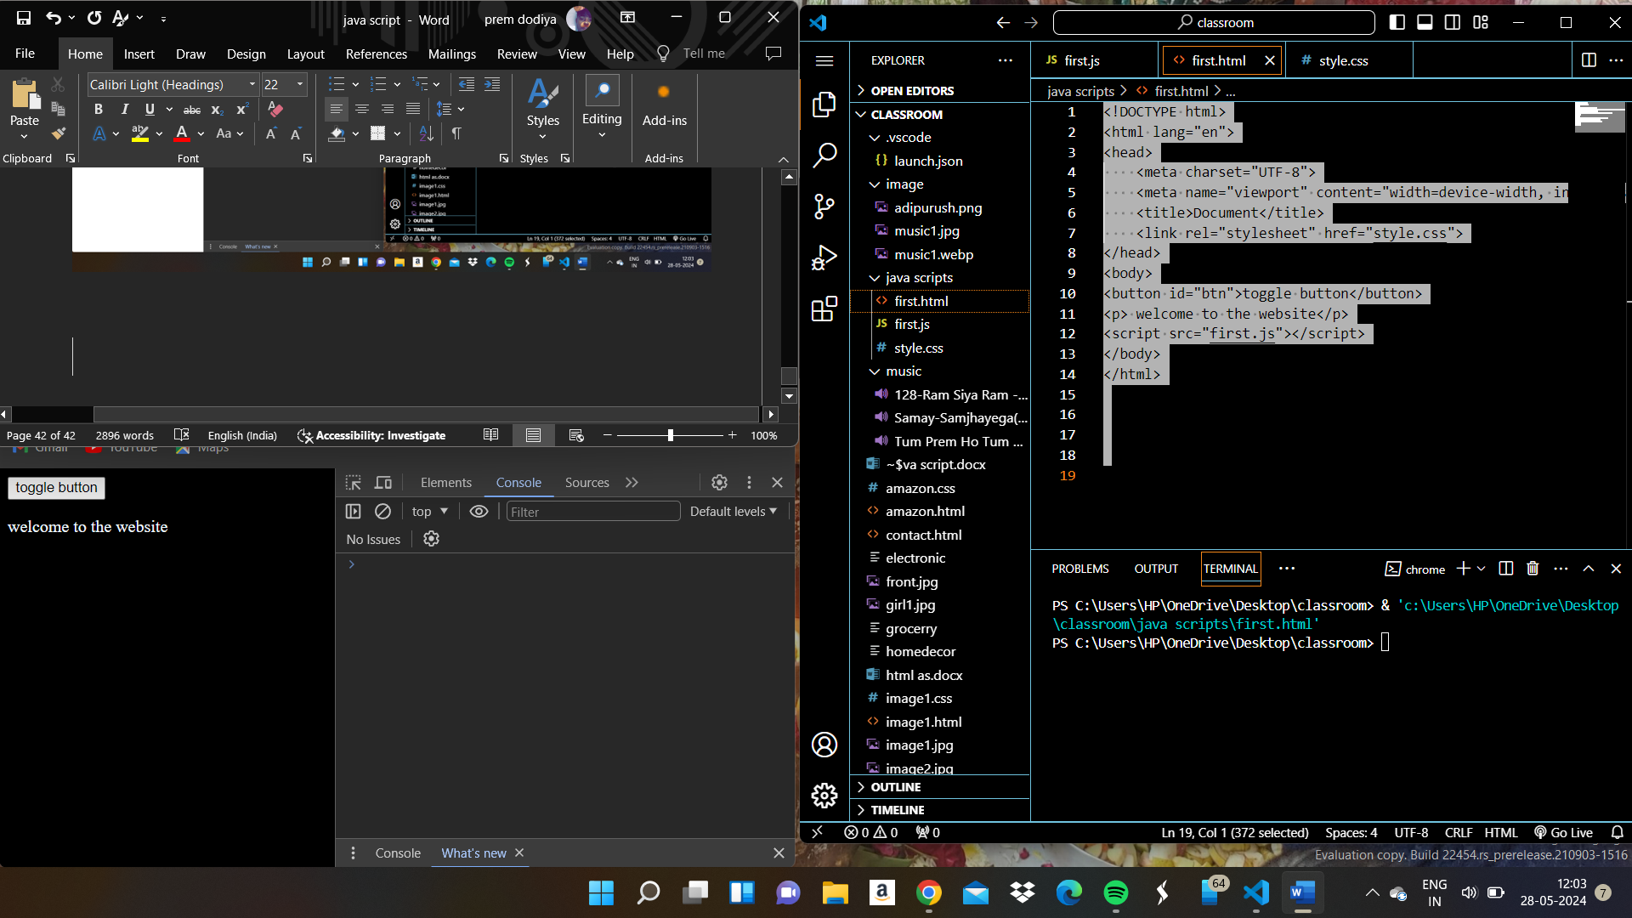

Homework

Mouseover event do have to do something

Create something to change the page

Mouse down events